Module 7
Transport layer Functions and Protocol
- The transport layer is the fourth layer in the OSI model and the second layer in the TCP/IP model. The transport layer is a 4th layer from the top.
- The main role of the transport layer is to provide the communication services directly to the application processes running on different hosts.
- The transport layer provides a logical communication between application processes running on different hosts. Although the application processes on different hosts are not physically connected, application processes use the logical communication provided by the transport layer to send the messages to each other.
- The transport layer protocols are implemented in the end systems but not in the network routers.
- A computer network provides more than one protocol to the network applications. For example, TCP and UDP are two transport layer protocols that provide a different set of services to the network layer.
- All transport layer protocols provide multiplexing/demultiplexing service. It also provides other services such as reliable data transfer, bandwidth guarantees, and delay guarantees.
- Each of the applications in the application layer has the ability to send a message by using TCP or UDP. The application communicates by using either of these two protocols. Both TCP and UDP will then communicate with the internet protocol in the internet layer. The applications can read and write to the transport layer. Therefore, we can say that communication is a two-way process.
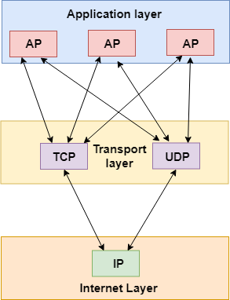

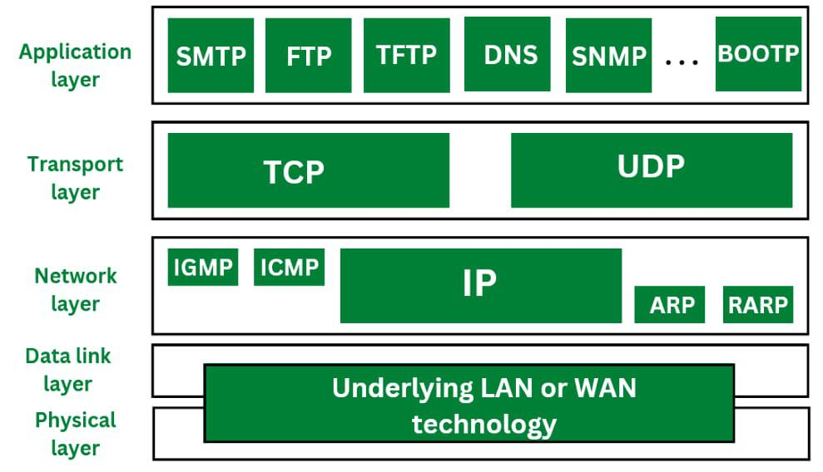

Services provided by the Transport Layer
The services provided by the transport layer are similar to those of the data link layer. The data link layer provides the services within a single network while the transport layer provides the services across an internetwork made up of many networks. The data link layer controls the physical layer while the transport layer controls all the lower layers.
The services provided by the transport layer protocols can be divided into five categories:
- End-to-end delivery
- Addressing
- Reliable delivery
- Flow control
- Multiplexing
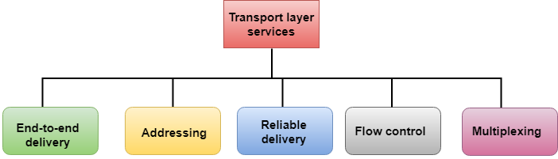

End-to-end delivery:
The transport layer transmits the entire message to the destination. Therefore, it ensures the end-to-end delivery of an entire message from a source to the destination.

Reliable delivery:
The transport layer provides reliability services by retransmitting the lost and damaged packets.

Functions of Transport Layer
- The process to process delivery
- End-to-end connection between devices
- Multiplexing and Demultiplexing
- Data integrity and error Correction
- Congestion Control
- Flow Control
Error Control
- The primary role of reliability is Error Control. In reality, no transmission will be 100 percent error-free delivery. Therefore, transport layer protocols are designed to provide error-free transmission.
- The data link layer also provides the error handling mechanism, but it ensures only node-to-node error-free delivery. However, node-to-node reliability does not ensure the end-to-end reliability.
- The data link layer checks for the error between each network. If an error is introduced inside one of the routers, then this error will not be caught by the data link layer. It only detects those errors that have been introduced between the beginning and end of the link. Therefore, the transport layer performs the checking for the errors end-to-end to ensure that the packet has arrived correctly.
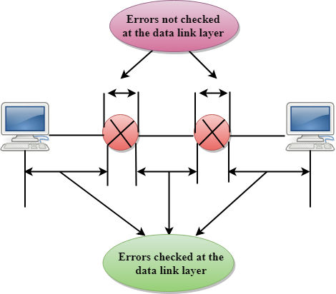
The error control function of the data link layer detects the errors in transmitted frames and re-transmits all the erroneous frames.
Purpose of Error Control :
The function of error control function of the data link layer helps in dealing with data frames that are damaged in transit, data frames lost in transit and acknowledged frames that are lost in transmission. The method used for error control is called Automatic Repeat Request (ARQ) which is used for the noisy channel.

Flow Control
Flow control is used to prevent the sender from overwhelming the receiver. If the receiver is overloaded with too much data, then the receiver discards the packets and asking for the retransmission of packets. This increases network congestion and thus, reducing the system performance. The transport layer is responsible for flow control. It uses the sliding window protocol that makes the data transmission more efficient as well as it controls the flow of data so that the receiver does not become overwhelmed. Sliding window protocol is byte oriented rather than frame oriented. It is an important function of the Data Link Layer. It refers to a set of procedures that tells the sender how much data it can transmit before waiting for acknowledgment from the receiver.

Note:
Flow control in transport layer ensures the delivery of the message globally, as the two points of connection over this protocol are logically connected.
Whereas in data-link layer, the concern is to deliver message locally, as the two points of connection over this protocol are physically connected.

Purpose of Flow Control:
Any receiving device has a limited speed at which it can process incoming data and also a limited amount of memory to store incoming data. If the source is sending the data at a faster rate than the capacity of the receiver, there is a possibility of the receiver being swamped. The receiver will keep losing some of the frames simply because they are arriving too quickly and the buffer is also getting filled up.
This will generate waste frames on the network. Therefore, the receiving device must have some mechanism to inform the sender to send fewer frames or stop transmission temporarily. In this way, flow control will control the rate of frame transmission to a value that can be handled by the receiver.

Stop and Wait Protocol
Before understanding the stop and Wait protocol, we first know about the error control mechanism. The error control mechanism is used so that the received data should be exactly same whatever sender has sent the data. The error control mechanism is divided into two categories, i.e., Stop and Wait ARQ and sliding window. The sliding window is further divided into two categories, i.e., Go Back N, and Selective Repeat. Based on the usage, the people select the error control mechanism whether it is stop and wait or sliding window.

What is Stop and Wait protocol?
Here stop and wait means, whatever the data that sender wants to send, he sends the data to the receiver. After sending the data, he stops and waits until he receives the acknowledgment from the receiver. The stop and wait protocol is a flow control protocol where flow control is one of the services of the data link layer.
It is a data-link layer protocol which is used for transmitting the data over the noiseless channels. It provides unidirectional data transmission which means that either sending or receiving of data will take place at a time. It provides flow-control mechanism but does not provide any error control mechanism.
The idea behind the usage of this frame is that when the sender sends the frame then he waits for the acknowledgment before sending the next frame.
The primitives of stop and wait protocol are:
Sender side
Rule 1: Sender sends one data packet at a time.
Rule 2: Sender sends the next packet only when it receives the acknowledgment of the previous packet.
Therefore, the idea of stop and wait protocol in the sender's side is very simple, i.e., send one packet at a time, and do not send another packet before receiving the acknowledgment.

Receiver side
Rule 1: Receive and then consume the data packet.
Rule 2: When the data packet is consumed, receiver sends the acknowledgment to the sender.
Therefore, the idea of stop and wait protocol in the receiver's side is also very simple, i.e., consume the packet, and once the packet is consumed, the acknowledgment is sent. This is known as a flow control mechanism.

Working of Stop and Wait protocol
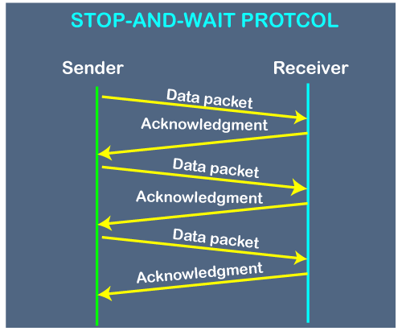
The above figure shows the working of the stop and wait protocol. If there is a sender and receiver, then sender sends the packet and that packet is known as a data packet. The sender will not send the second packet without receiving the acknowledgment of the first packet. The receiver sends the acknowledgment for the data packet that it has received. Once the acknowledgment is received, the sender sends the next packet. This process continues until all the packet are not sent. The main advantage of this protocol is its simplicity but it has some disadvantages also. For example, if there are 1000 data packets to be sent, then all the 1000 packets cannot be sent at a time as in Stop and Wait protocol, one packet is sent at a time.

Disadvantages of Stop and Wait protocol
The following are the problems associated with a stop and wait protocol:
1. Problems occur due to lost data
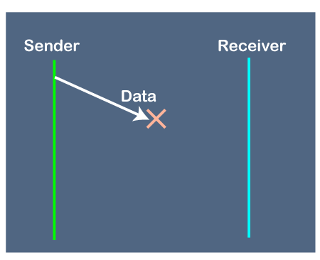
Suppose the sender sends the data and the data is lost. The receiver is waiting for the data for a long time. Since the data is not received by the receiver, so it does not send any acknowledgment. Since the sender does not receive any acknowledgment so it will not send the next packet. This problem occurs due to the lost data.
In this case, two problems occur:
ADVERTISEMENT
- Sender waits for an infinite amount of time for an acknowledgment.
- Receiver waits for an infinite amount of time for a data.
2. Problems occur due to lost acknowledgment
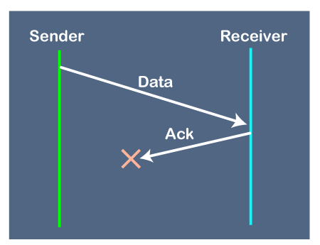
Suppose the sender sends the data and it has also been received by the receiver. On receiving the packet, the receiver sends the acknowledgment. In this case, the acknowledgment is lost in a network, so there is no chance for the sender to receive the acknowledgment. There is also no chance for the sender to send the next packet as in stop and wait protocol, the next packet cannot be sent until the acknowledgment of the previous packet is received.
In this case, one problem occurs:
- Sender waits for an infinite amount of time for an acknowledgment.
3. Problem due to the delayed data or acknowledgment
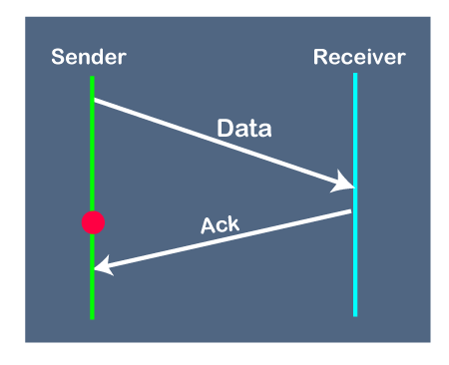
Suppose the sender sends the data and it has also been received by the receiver. The receiver then sends the acknowledgment but the acknowledgment is received after the timeout period on the sender's side. As the acknowledgment is received late, so acknowledgment can be wrongly considered as the acknowledgment of some other data packet.

Sliding Window Protocol
The sliding window is a technique for sending multiple frames at a time. It controls the data packets between the two devices where reliable and gradual delivery of data frames is needed. It is also used in TCP (Transmission Control Protocol).
In this technique, each frame has sent from the sequence number. The sequence numbers are used to find the missing data in the receiver end. The purpose of the sliding window technique is to avoid duplicate data, so it uses the sequence number.

Types of Sliding Window Protocol
Sliding window protocol has two types:
- Go-Back-N ARQ
- Selective Repeat ARQ

Go-Back-N ARQ
Go-Back-N ARQ protocol is also known as Go-Back-N Automatic Repeat Request. It is a data link layer protocol that uses a sliding window method. In this, if any frame is corrupted or lost, all subsequent frames have to be sent again.
The size of the sender window is N in this protocol. For example, Go-Back-8, the size of the sender window, will be 8. The receiver window size is always 1.
If the receiver receives a corrupted frame, it cancels it. The receiver does not accept a corrupted frame. When the timer expires, the sender sends the correct frame again. The design of the Go-Back-N ARQ protocol is shown below.
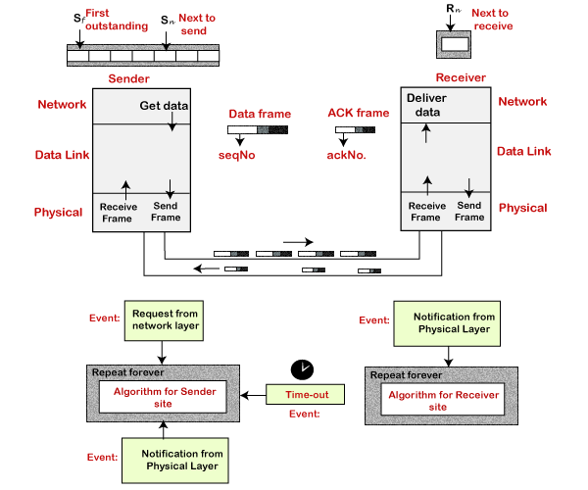
The example of Go-Back-N ARQ is shown below in the figure.
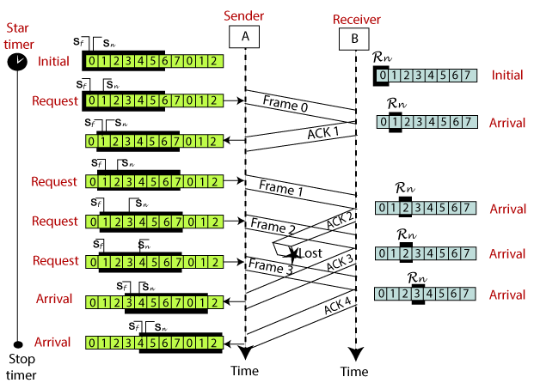

Selective Repeat ARQ
Selective Repeat ARQ is also known as the Selective Repeat Automatic Repeat Request. It is a data link layer protocol that uses a sliding window method. The Go-back-N ARQ protocol works well if it has fewer errors. But if there is a lot of error in the frame, lots of bandwidth loss in sending the frames again. So, we use the Selective Repeat ARQ protocol. In this protocol, the size of the sender window is always equal to the size of the receiver window. The size of the sliding window is always greater than 1.
If the receiver receives a corrupt frame, it does not directly discard it. It sends a negative acknowledgment to the sender. The sender sends that frame again as soon as on the receiving negative acknowledgment. There is no waiting for any time-out to send that frame. The design of the Selective Repeat ARQ protocol is shown below.
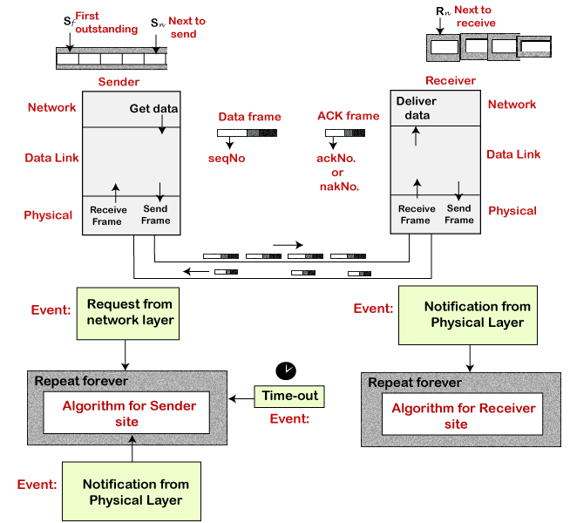
The example of the Selective Repeat ARQ protocol is shown below in the figure.
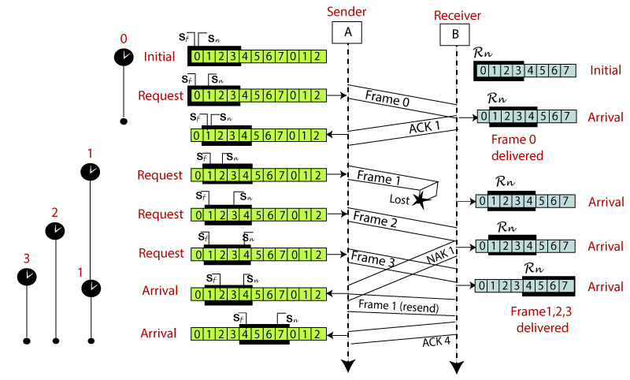

Difference between the Go-Back-N ARQ and Selective Repeat ARQ?
Go-Back-N ARQ | Selective Repeat ARQ
If a frame is corrupted or lost in it,all subsequent frames have to be sent again. | In this, only the frame is sent again, which is corrupted or lost.
If it has a high error rate,it wastes a lot of bandwidth. | There is a loss of low bandwidth.
It is less complex. | It is more complex because it has to do sorting and searching as well. And it also requires more storage.
It does not require sorting. | In this, sorting is done to get the frames in the correct order.
It does not require searching. | The search operation is performed in it.
It is used more. | It is used less because it is more complex.

Connection establishment and release: Three way handshaking
Transmission Control Protocol (TCP) provides a secure and reliable connection between two devices using the 3-way handshake process. TCP uses the full-duplex connection to synchronize (SYN) and acknowledge (ACK) each other on both sides. There are three steps for both establishing and closing a connection. They are − SYN, SYN-ACK, and ACK.

3-Way Handshake Connection Establishment Process
The following diagram shows how a reliable connection is established using 3-way handshake. It will support communication between a web browser on the client and server sides whenever a user navigates the Internet.
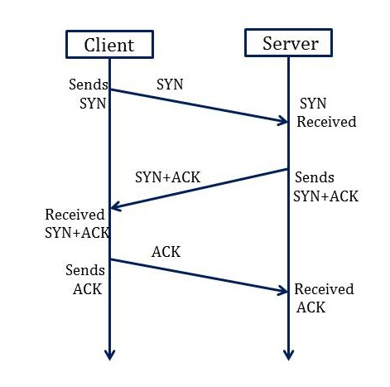

Synchronization Sequence Number (SYN) − The client sends the SYN to the server
- When the client wants to connect to the server, then it sends the message to the server by setting the SYN flag as 1.
- The message carries some additional information like the sequence number (32-bit random number).
- The ACK is set to 0. The maximum segment size and the window size are also set. For example, if the window size is 1000 bits and the maximum segment size is 100 bits, then a maximum of 10 data segments can be transmitted in the connection by dividing (1000/100=10).

Synchronization and Acknowledgement (SYN-ACK) to the client
- The server acknowledges the client request by setting the ACK flag to 1.
- The ACK indicates the response of the segment it received and SYN indicates with what sequence number it will start the segments.
- For example, if the client has sent the SYN with sequence number = 500, then the server will send the ACK using acknowledgment number = 5001.
- The server will set the SYN flag to '1' and send it to the client if the server also wants to establish the connection.
- The sequence number used for SYN will be different from the client's SYN.
- The server also advertises its window size and maximum segment size to the client. And, the connection is established from the client-side to the server-side.

Acknowledgment (ACK) to the server
- The client sends the acknowledgment (ACK) to the server after receiving the synchronization (SYN) from the server.
- After getting the (ACK) from the client, the connection is established between the client and the server.
- Now the data can be transmitted between the client and server sides.

3 -Way Handshake Closing Connection Process
To close a 3-way handshake connection,
- First, the client requests the server to terminate the established connection by sending FIN.
- After receiving the client request, the server sends back the FIN and ACK request to the client.
- After receiving the FIN + ACK from the server, the client confirms by sending an ACK to the server.
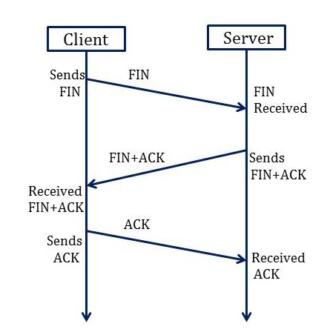

Transport Layer Protocols
The transport layer is represented majorly by TCP and UDP protocols. Today almost all operating systems support multiprocessing multi-user environments. This transport layer protocol provides connections to the individual ports. These ports are known as protocol ports. Transport layer protocols work above the IP protocols and deliver the data packets from IP serves to destination port and from the originating port to destination IP services. Below are the protocols used at the transport layer.

1. UDP
UDP stands for User Datagram Protocol. User Datagram Protocol provides a nonsequential transmission of data. It is a connectionless transport protocol. UDP protocol is used in applications where the speed and size of data transmitted is considered as more important than the security and reliability. User Datagram is defined as a packet produced by User Datagram Protocol. UDP protocol adds checksum error control, transport level addresses, and information of length to the data received from the layer above it. Services provided by User Datagram Protocol(UDP) are connectionless service, faster delivery of messages, checksum, and process-to-process communication.
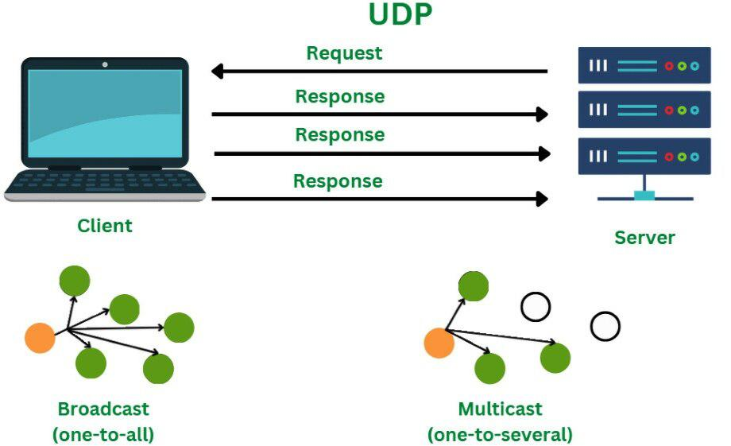

UDP Segment
While the TCP header can range from 20 to 60 bytes, the UDP header is a fixed, basic 8 bytes. All required header information is contained in the first 8 bytes, with data making up the remaining portion. Because UDP port number fields are 16 bits long, the range of possible port numbers is defined as 0 to 65535, with port 0 being reserved.
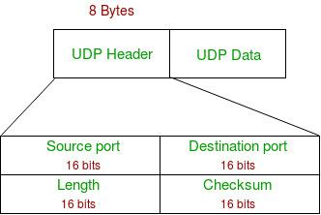
UDP
- Source Port: Source Port is a 2 Byte long field used to identify the port number of the source.
- Destination Port: This 2-byte element is used to specify the packet’s destination port.
- Length: The whole length of a UDP packet, including the data and header. The field has sixteen bits.
- Cheksum: The checksum field is two bytes long. The data is padded with zero octets at the end (if needed) to create a multiple of two octets. It is the 16-bit one’s complement of the one’s complement sum of the UDP header, the pseudo-header containing information from the IP header, and the data.

Advantages of UDP
- UDP also provides multicast and broadcast transmission of data.
- UDP protocol is preferred more for small transactions such as DNS lookup.
- It is a connectionless protocol, therefore there is no compulsion to have a connection-oriented network.
- UDP provides fast delivery of messages.

Disadvantages of UDP
- In UDP protocol there is no guarantee that the packet is delivered.
- UDP protocol suffers from worse packet loss.
- UDP protocol has no congestion control mechanism.
- UDP protocol does not provide the sequential transmission of data.

2. TCP
TCP stands for Transmission Control Protocol. TCP protocol provides transport layer services to applications. TCP protocol is a connection-oriented protocol. A secured connection is being established between the sender and the receiver. For a generation of a secured connection, a virtual circuit is generated between the sender and the receiver. The data transmitted by TCP protocol is in the form of continuous byte streams. A unique sequence number is assigned to each byte. With the help of this unique number, a positive acknowledgment is received from receipt. If the acknowledgment is not received within a specific period the data is retransmitted to the specified destination.
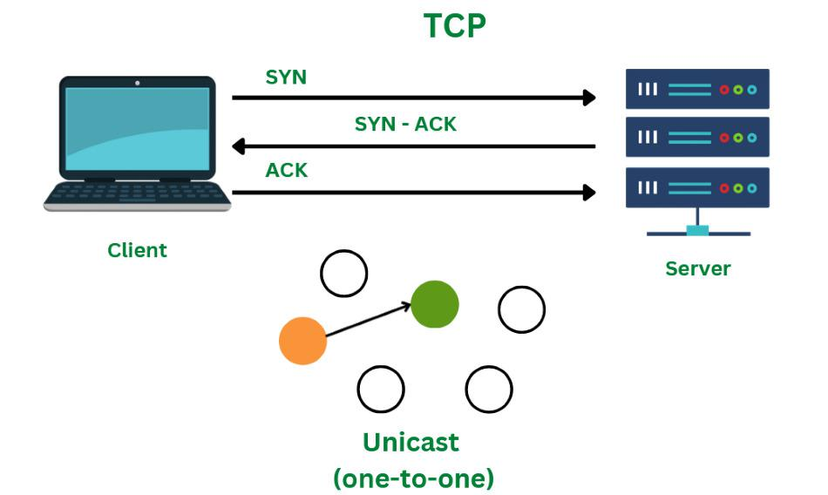

TCP Segment
A TCP segment’s header may have 20–60 bytes. The options take about 40 bytes. A header consists of 20 bytes by default, although it can contain up to 60 bytes.
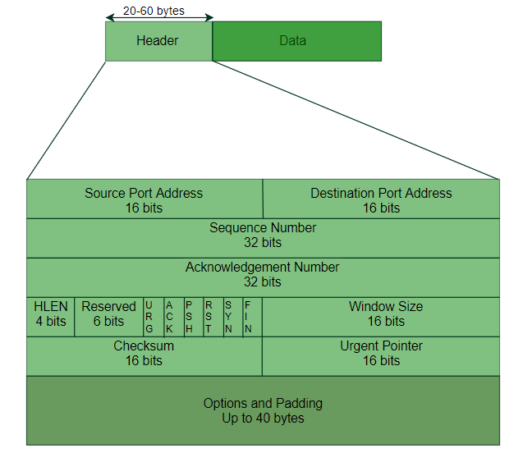
- Source Port Address: The port address of the programme sending the data segment is stored in the 16-bit field known as the source port address.
- Destination Port Address: The port address of the application running on the host receiving the data segment is stored in the destination port address, a 16-bit field.
- Sequence Number: The sequence number, or the byte number of the first byte sent in that specific segment, is stored in a 32-bit field. At the receiving end, it is used to put the message back together once it has been received out of sequence.
- Acknowledgement Number : The acknowledgement number, or the byte number that the recipient anticipates receiving next, is stored in a 32-bit field called the acknowledgement number. It serves as a confirmation that the earlier bytes were successfully received.
- Header Length (HLEN): This 4-bit field stores the number of 4-byte words in the TCP header, indicating how long the header is. For example, if the header is 20 bytes (the minimum length of the TCP header), this field will store 5 because 5 x 4 = 20, and if the header is 60 bytes (the maximum length), it will store 15 because 15 x 4 = 60. As a result, this field’s value is always between 5 and 15.
- Control flags: These are six 1-bit control bits that regulate flow control, method of transfer, connection abortion, termination, and establishment. They serve the following purposes:
  - Urgent: This pointer is legitimate
  - ACK: The acknowledgement number (used in cumulative acknowledgement cases) is valid.
  - PSH: Push request
  - RST: Restart the link.
  - SYN: Sequence number synchronisation
  - FIN: Cut off the communication
  - Window size: This parameter provides the sender TCP’s window size in bytes.
- Checksum: The checksum for error control is stored in this field. Unlike UDP, it is required for TCP.
- Urgent pointer: This field is used to point to data that must urgently reach the receiving process as soon as possible. It is only valid if the URG control flag is set. To obtain the byte number of the final urgent byte, the value of this field is appended to the sequence number.

Advantages of TCP
- TCP supports multiple routing protocols.
- TCP protocol operates independently of that of the operating system.
- TCP protocol provides the features of error control and flow control.
- TCP provides a connection-oriented protocol and provides the delivery of data.

Disadvantages of TCP
- TCP protocol cannot be used for broadcast or multicast transmission.
- TCP protocol has no block boundaries.
- No clear separation is being offered by TCP protocol between its interface, services, and protocols.
- In TCP/IP replacement of protocol is difficult.

3. SCTP
SCTP stands for Stream Control Transmission Protocol. SCTP is a connection-oriented protocol. Stream Control Transmission Protocol transmits the data from sender to receiver in full duplex mode. SCTP is a unicast protocol that provides with point to point-to-point connection and uses different hosts for reaching the destination. SCTP protocol provides a simpler way to build a connection over a wireless network. SCTP protocol provides a reliable transmission of data. SCTP provides a reliable and easier telephone conversation over the internet. SCTP protocol supports the feature of multihoming ie. it can establish more than one connection path between the two points of communication and does not depend on the IP layer. SCTP protocol also ensures security by not allowing the half-open connections.
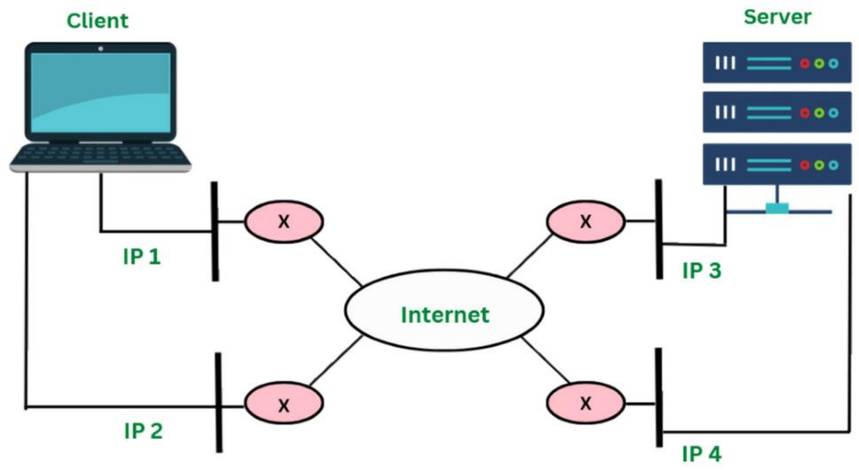

Advantages of SCTP
- SCTP provides a full duplex connection. It can send and receive the data simultaneously.
- SCTP protocol possesses the properties of both TCP and UDP protocol.
- SCTP protocol does not depend on the IP layer.
- SCTP is a secure protocol.

Disadvantages of SCTP
- To handle multiple streams simultaneously the applications need to be modified accordingly.
- The transport stack on the node needs to be changed for the SCTP protocol.
- Modification is required in applications if SCTP is used instead of TCP or UDP protocol.
Questions-Answer

How does the SCTP protocol provide more security?
SCTP makes use of 4-way handshake whereas TCP makes use of 3-way handshake. SCTP provides with protection against SYN flooding attacks, man in the middle attack, large cookies and half open connections.

What are the advantages of SCTP over TCP protocol?
The advantages of SCTP over TCP are SCTP has a fault tolerance mechanism and provides with protection against the attacks such as SYN flooding, man in the middle etc.

Comparing TCP and UDP which protocol is faster?
Comparing TCP and UDP, UDP protocol is faster and more efficient as compared to TCP. UDP protocol is a connectionless protocol and does not need to establish any connection for transmission of data.

What is the use of a port in IP?
Port number is used to identify a specific service or application on the system.

How TCP ensures reliability?
TCP ensures reliability through a mechanism called thrre-way Handshakeing mechanism.

